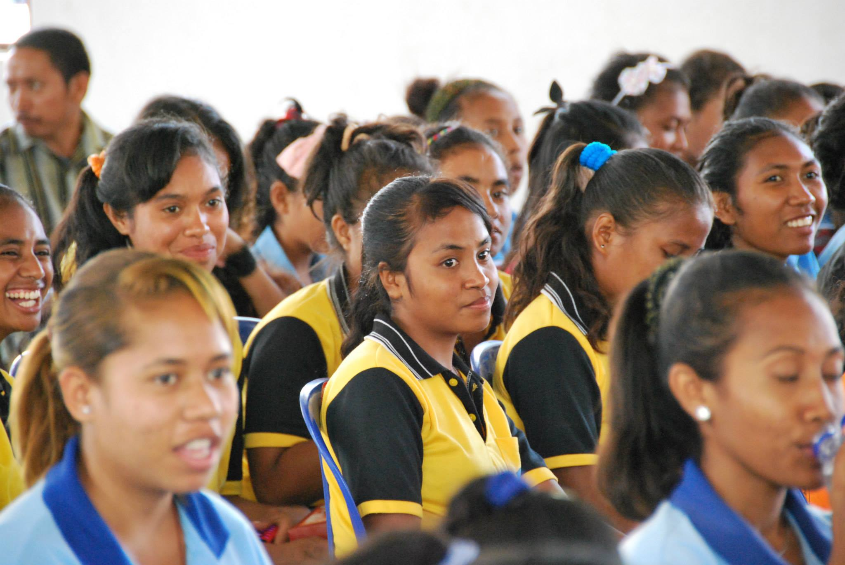
Who We Are
Credit: Fitsum T./UNFPA

UNFPA: Delivering a world where every pregnancy is wanted,
every childbirth is safe and every young person’s potential is fulfilled.

UNFPA (The United Nations Population Fund) is the lead UN agency for delivering a world where every pregnancy is wanted, every birth is safe, and every young person's potential is fulfilled.

UNFPA promotes the right of every woman, man and child to enjoy a life of health and equal opportunity. Since UNFPA started working in 1969, there has been real progress - the number - and rate - of women dying from complications of pregnancy or childbirth has been halved. Families are smaller and healthier. Young people are more connected and empowered than ever before.

UNFPA supports countries in using population data for policies and programme to reduce poverty. The information generated by a population and housing census – numbers of people, their distribution, their living conditions and other key data – is critical for development. Without accurate data, policymakers do not know where to invest in schools, hospitals and roads. Those most in need remain invisible.
How We Help Timor-Leste
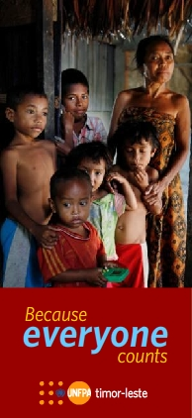

Since 2003, UNFPA Timor-Leste has supported governmental and nongovernmental organizations activities to address population issues and has strongly promoted reproductive rights and gender equality as key elements to achieve human rights and human dignity. Key activities and achievements include support to the 2004 and 2010 population and housing censuses; development, advocacy and approval of the law against domestic violence and approval of a national action plan on gender-based violence; standardization of the midwifery curriculum at the National University of Timor-Leste; and revision of the national reproductive health strategy.

2015 marks the first year of UNFPA’s third 5-year Country Programme whose overall goal is to create an enabling environment for sexual and reproductive health, while strengthening capacities, targeting interventions for the underserved and addressing inequalities. The Country Programme will focus on capacity development of the Ministry of Health and relevant national institutions to avert maternal mortality, reduce the unmet need for family planning, and to prevent and respond to gender-based violence. Increased priority will be given to programmes targeted to youth and increase the availability of comprehensive sexuality education and sexual and reproductive health. The institutional capacity of the General Directorate for Statistics and national institutions to plan, collect, process, analyse, and disseminate reliable and up-to-date data will be strengthened. Evidence-based advocacy and policy dialogue will continue to promote reproductive health and rights, empower young people and effectively respond to gender-based violence.

Address: United Nations Population Fund (UNFPA)
UN House, Caicoli Street, Dili, Timor-Leste
Tel: +670 3312618
Website: http://countryoffice.unfpa.org/timor-leste
Facebook: UNFPA Timor-Leste
Twitter: @UNFPATimor

Stay in touch:
United Nations Population Fund (UNFPA)
UN House, Caicoli Street, Dili, Timor-Leste
Tel: +670 3312618
Website: http://countryoffice.unfpa.org/timor-leste
Facebook: UNFPA Timor-Leste
Twitter: UNFPA Timor-Leste

